|  |
| --- |
| **Institutional Quality Assurance Process (IQAP)** |

**Faculty CVs for New Program– Instructions:**

The CVs of all faculty members in the AAU proposing the new program should be appended to the *PDC Form A “Proposal Brief for New programs*”, as well as the CVs of faculty members from other AAUs who are core to the delivery of the proposed program. The CVs can be obtained from the University’s eCV system as an Adobe pdf file:

1. Each faculty member should ensure that their eCV is up-to-date and that relevant information in the eCV is entered under the correct sections and categories.
2. The IQAP-formatted CVs can be obtained by logging into each faculty member’s eCV, selecting the “*Read/Print eCV*” tab, and selecting the “*IQAP CV*” (see figure below). Each faculty member can obtain their CV as a pdf file and submit it to a designated person in the department who will collect all CVs; alternatively, each faculty member can delegate access to their eCV to a designated person in the department using the “*Who can access my eCV*” tab on their main eCV menu.

***Screenshot of Read/Print tab on the eCV system:***

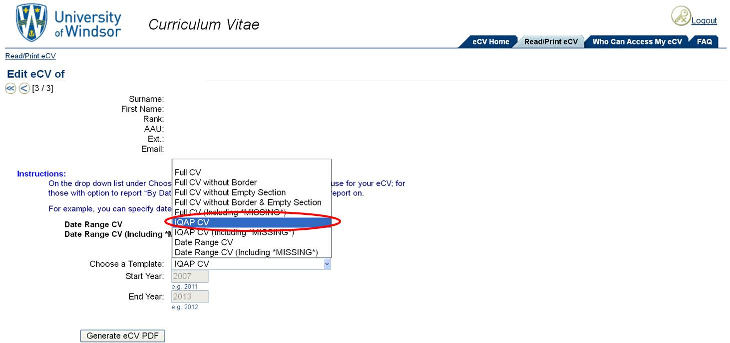

1. The individual pdfs of each faculty member CV are combined in a **single pdf document**, with a Table of Contents included. Faculty CVs must be grouped under the same categories as in the faculty table in section “*Available faculty and staff resources*” of *PDC Form A “Proposal Brief for New programs” (see next page for sample CV document structure).*

\**other standardized CV formats are acceptable as well, such as that used by one of the Tri-Councils- contact the Office of Quality Assurance for guidance*



**Department of Biology**

**Curricula Vitae of Faculty Members**

**Table of Contents**

|  |  |  |
| --- | --- | --- |
| **Name** | **Title**  **(AAU/ Institution, if different from**  **that under review)** | **Page #** |
| **Category 1: Tenured Professors teaching exclusively in this AAU** | | |
| Doe, John | Professor | 4 |
| Evans, Peter | Associate Professor | 5 |
| Richie, Anthony | Assistant Professor | 11 |
| **Category 2: Tenure-track Professors teaching exclusively in this AAU** | | |
|  |  |  |
| **Category 3: Ancillary Academic Staff as Learning Specialists Positions** | | |
| Davids, Myra | AAS | 14 |
| **Category 4: Sessional lecturers** | | |
| Walters, Tawney | Sessional Lecturer | 23 |
| Gleeson, Timothy | Sessional Lecturer |  |
| **Category 5: Limited-term Appointments teaching exclusively in this AAU** | | |
|  |  |  |
| **Category 6: Tenure or tenure-track or LTA professors involved in teaching and/or supervision in other AAUs, in addition to being a member of the program under review** | | |
| Owens, Beth | Cross-Appointed, Professor, (Earth Science) | 27 |
| Christianson, David | Assistant Professor, (Chemistry) | 32 |
| **Category 7: Sessional instructors and other non-tenure track faculty** | | |
| Jones, Beverly | Sessional Instructor | 36 |
| **Category 8: Others.** | | |
| Thompson, Maryanne | Adjunct Professor, (Biology- University of Michigan) | 40 |
| Luck, Wesley | Professor Emeriti, Biology | 45 |

* If you do not have faculty in a category you can leave it blank or insert “N/A”

2

**Category 1: Tenured Professors teaching   
 exclusively in this AAU**

3

CURRICULUM VITAE

a) NAME:

**DOE, John,** Professor, tenured

Member of the Graduate Faculty: Yes

b) DEGREES AND PROFESSIONAL DESIGNATIONS:

Ph.D. Biological Science, University of London, U.K., 1986

MSc., Biological Science, University of Alberta, 1981

B.Sc., Biochemistry, University of Toronto, 1978

c) EMPLOYMENT HISTORY:

2003/07/01- Present Professor, Department of Biology, University of Windsor

2001/07/01- 2003/06/30 Associate Professor, Department of Biology, University of Windsor

1995/07/01-2001/06/30 Assistant Professor, Dept. of Biology, University of Windsor

1990/04/22-1995/06/30 Assistant Professor, Dept. of Biology, University of Copenhagen

d) HONOURS:

Senior Staff Award, University of Windsor, 2000

Merit Award, University of Windsor, 1998

Professor of the Decade Aware, University of Copenhagen, 1992

e) SCHOLARLY AND PROFESSIONAL ACTIVITIES (**past 7 years only)**

2006-Present Ext. Assessor of Graduate Programs, History, Moon University

2007-08 Member, Editorial Board, Journal of Biotechnology

f) UNDERGRADUATE SUPERVISIONS:

Completed: 5

In progress: 1

NAMES OF STUDENTS (supervised within the **past seven years only)**:

* Garth Hanmer (B.Sc.), Project title, Sept. 2015- Present (Thesis/Dissertation)
* Victoria Shamowski (B.Sc.), Project title, Sept. 2013-June 2014 (directed study)

g) GRADUATE SUPERVISIONS:

Completed: 2 Doctoral (Supervisor), 2 Doctoral (Co-Supervisor), 8 Master’s (Supervisor)

In progress: 1 Doctoral (Supervisor), 2 Master’s (Supervisor)

NAMES OF STUDENTS supervised within the **past seven years**:

* Gwen Lewis (PhD), Dissertation Title, Sept. 2012- Present (Thesis/Dissertation)
* Dylan Thomas (MSc.), Thesis title,. Sept. 2013-present (Thesis/Dissertation)**……………**

4

CURRICULUM VITAE

a) NAME:

**Evans, Peter,** Associate Professor, tenured

Member of the Graduate Faculty: Yes

b) DEGREES AND PROFESSIONAL DESIGNATIONS:

Ph.D. Biology Science, UCLA, USA., 1999

MSc., Ecology, Biodiversity & Conservation, University of Melbourne, 1995

B.Sc., Biology, University of Melbourne, 1990

c) EMPLOYMENT HISTORY:

2010/07/01- Present Associate Professor, Department of Biology, University of Windsor

2005/07/01-2010/06/30 Assistant Professor, Dept. of Biology, University of Windsor

2003/08/01-2005/05/30 Ecological Research Consultant, Integral Ecology Research Center, California, USA.

1999/05/05-2003/04/30 Sessional Instructor, Dept. of Biology, UCLA, USA

d) HONOURS:

Best Dissertation Proposal, Ecological Research Society of California, 1997

Most Promising Future Environmental Researcher, Government of Australia, 1995

Teaching Assistant of the Year, University of Melbourne, 1993

e) SCHOLARLY AND PROFESSIONAL ACTIVITIES (**past 7 years only)**

2012-Present External Project Review Panel, Ecological Research Center, California, USA

2009-2015 Member, Editorial Board, Ecological Research and Studies.

f) UNDERGRADUATE SUPERVISIONS:

Completed: 0

In progress: 0

NAMES OF STUDENTS (supervised within the **past seven years only)**:

g) GRADUATE SUPERVISIONS:

Completed: 1 Master’s (Supervisor)

In progress: 0 Doctoral (Supervisor), 1 Master’s (Supervisor)

NAMES OF STUDENTS supervised within the **past seven years**:

* David Parsons (MSc.), Thesis title, Sept. 2014- Present (Thesis/Dissertation)
* Nathan Lavin (MSc.), Thesis title,. Sept. 2011-2014 (Thesis/Dissertation)**……………**

5

**Category 3: Ancillary Academic Staff as Learning**

**Specialists Positions**

6

CURRICULUM VITAE

a) NAME:

**Davids, Myra,** AAS/Learning Specialist II,

Member of the Graduate Faculty: No

b) DEGREES AND PROFESSIONAL DESIGNATIONS:

Ph.D. Biological Science, University of London, U.K., 2010

MSc., Biological Science, University of Alberta, 2005

B.Sc., Biochemistry, University of Toronto, 2002

c) EMPLOYMENT HISTORY:

2014/09/01- Present AAS/Learning Specialist II, Faculty of Science, University of Windsor

2012/09/10- 2014/08/31 Sessional Instructor, Dept. of Biology, University of Windsor

2010/01/15-2012/05/31 Research Assistant, Ontario Center for Biological Research and Testing, Toronto, ON.

d) HONOURS:

Science Thesis of the Year, 2005

Phillip Reed Medal of Innovation, 2003

e) SCHOLARLY AND PROFESSIONAL ACTIVITIES (**past 7 years only)**

2012 Judge, Innovation Competition, Center for Biotechnological Innovation

f) UNDERGRADUATE SUPERVISIONS:

Completed: 0

In progress: 0

NAMES OF STUDENTS (supervised within the **past seven years only)**:

g) GRADUATE SUPERVISIONS:

Completed:

In progress:

NAMES OF STUDENTS supervised within the **past seven years**:**…………**.

7

**Category 4: Sessional lecturers**

8

CURRICULUM VITAE

a) NAME:

**Jones, Beverly,** Sessional Lecturer,

Member of the Graduate Faculty: No

b) DEGREES AND PROFESSIONAL DESIGNATIONS:

Ph.D. Botany, University of British Columbia, 2008

MSc., Botany, University of British Columbia, 2003

B.Sc., Biology, University of Toronto, 2000

c) EMPLOYMENT HISTORY:

2009/09/01- Present Sessional Lecturer, Department of Biology, University of Windsor

2009/05/21-Present Botany Research Specialist, Ojibway Nature Center, Windsor, ON

2008/07/01- 2009/06/30 Research Coordinator, Botany Canada, Toronto, ON

2004/09/01-2008/04/30 Teaching Assistant, Dept. of Biology, University of British Columbia

d) HONOURS:

2012 Lawson Medal, Canadian Botanical Association

2008 Most Innovative Research Paper, University of British Columbia

e) SCHOLARLY AND PROFESSIONAL ACTIVITIES (**past 7 years only)**

2015-Present Editor, Botanical Review of Southwestern Ontario.

2012-2014 Event Coordinator, Young Botanists of Ontario, Annual Conference

f) UNDERGRADUATE SUPERVISIONS:

Completed: 0

In progress: 0

NAMES OF STUDENTS (supervised within the **past seven years only)**:

g) GRADUATE SUPERVISIONS:

Completed:

In progress:

NAMES OF STUDENTS supervised within the **past seven years**:**…………**.

9