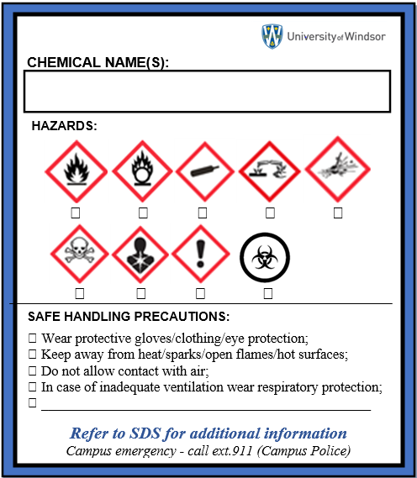
WHMIS 2015 University of Windsor Workplace Label

