Use Banner Images Provided by Brightspace Elsewhere in the Course

D2L Brightspace has provided over 3,000 images that can be selected for the banner on the home page of your course. These images can also be used elsewhere in your course, such as in your Content area for your descriptions, with a few steps.

Retrieve the banner image link
- Go to the Course Home of a course site and click on the 3 dots > Change Image in the banner image to open the image searcher.
- Type in a search term in the box and press enter.
- Right-click somewhere in the image you want but NOT on the Use this image button.
- Select the Copy image link (Firefox) or Copy image address (Chrome) from the right-click menu.
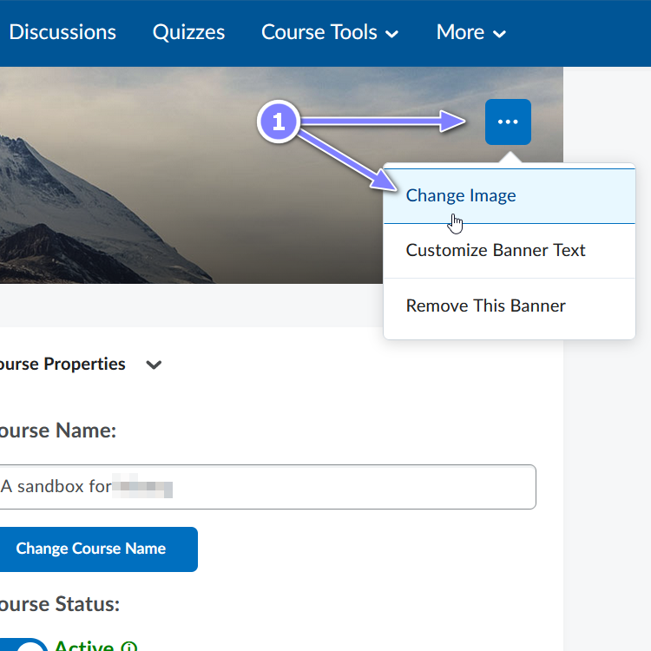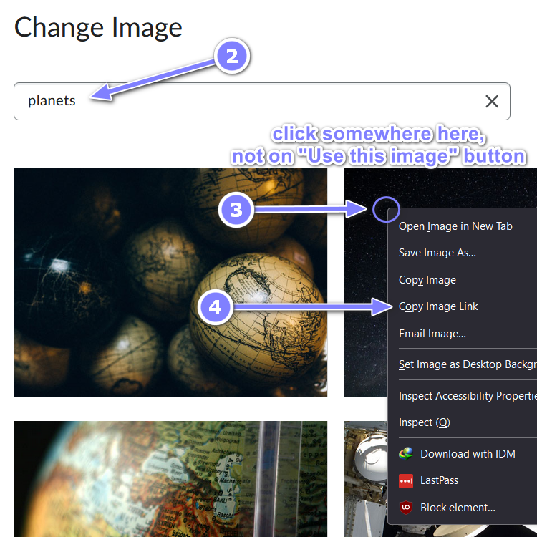

Inserting the banner image in text editor
- When in a text editor, click on the Insert Image icon.
- Select the URL option.
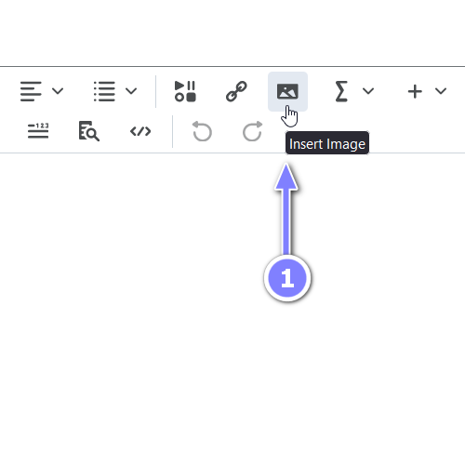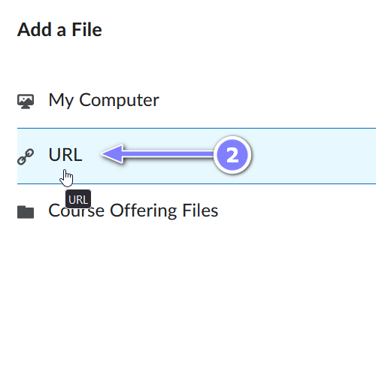
- Paste in the link you’ve copied earlier into the URL field and click Add.
- Provide an alternative text and click on OK.
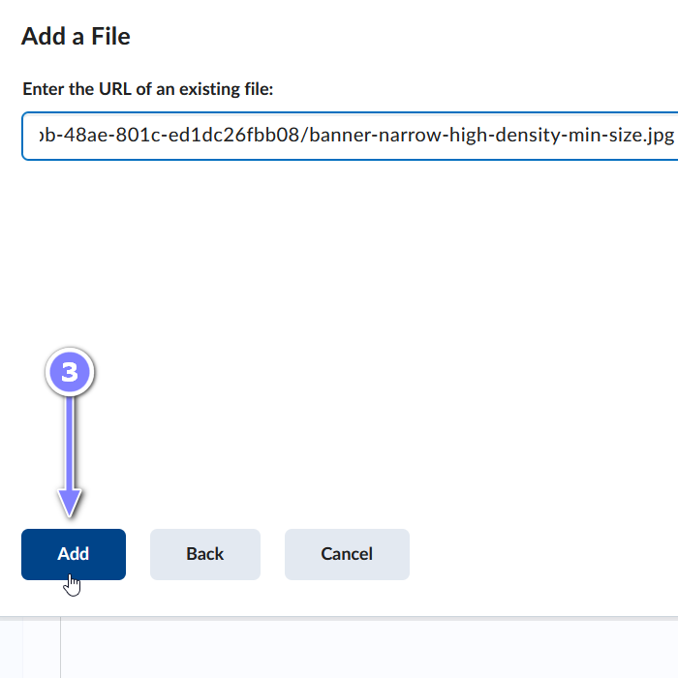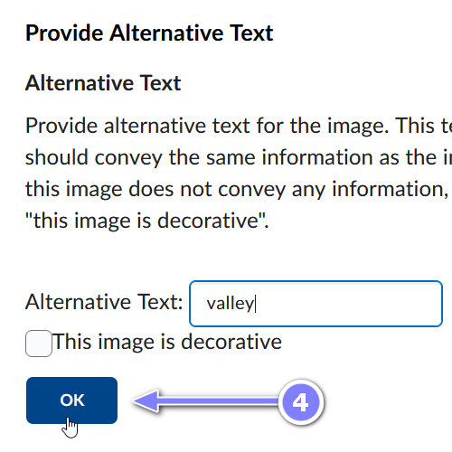
- The banner image should now be visible in your text editor.
