How to view ungraded assignments

- Click Assignments in the nav bar.
- Click on the chevron (downward arrow) next to the assignment for which you want to view the ungraded list and select View Submissions.
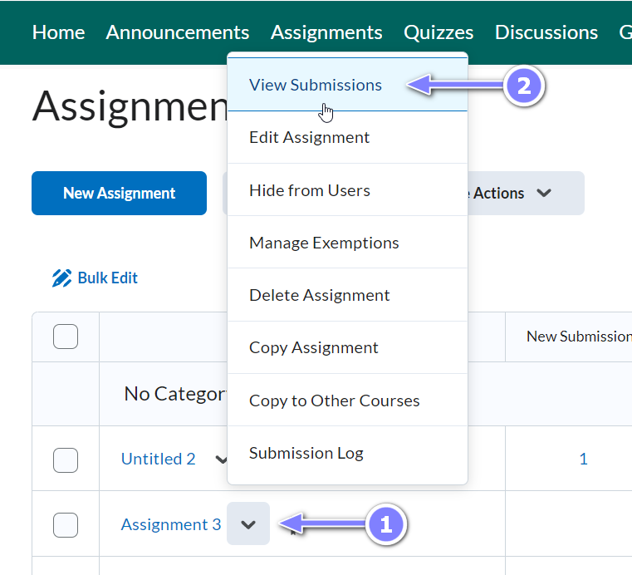
- Click on the Show Search Option.
- Select Users with submissions under Submissions drop-down.
- Check the Only show users with unread submissions checkbox below. 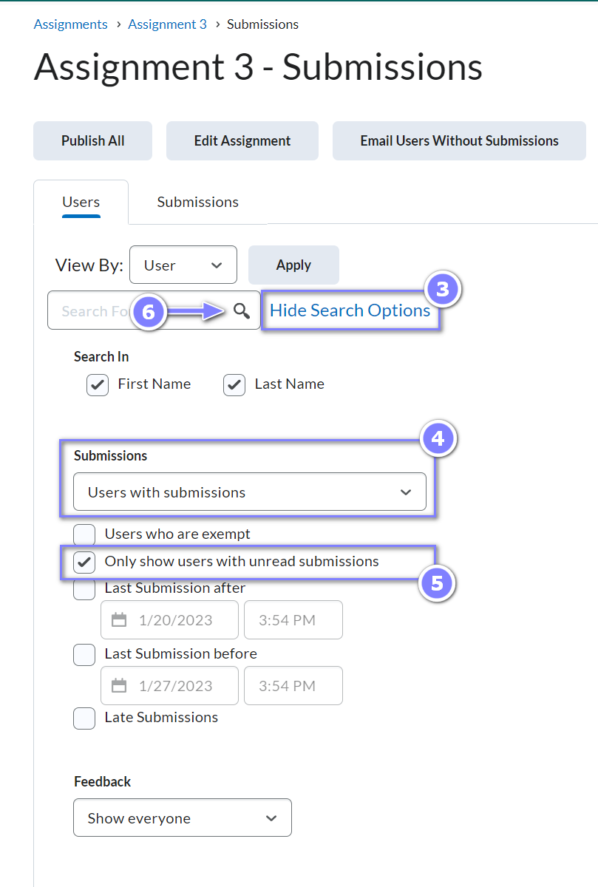
- Click on the magnifying icon to perform the search. You’ll now see a list of submissions that needs to be graded.
  - Note: the only issue with this method is if a GA/TA clicks on the submission icon itself, the item will be automatically set to read but if the GA/TA clicks on the student’s name to view, the assignment will not be marked as read and the GA/TA will need to set it as read manually.
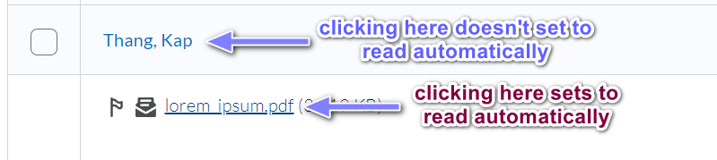

- You can also do a search via the Submissions tab. The view in the Submissions tab is more compact, providing each student’s submission on one line. Rather than the Submissions drop-down that is seen in the Users tab, use the Read Status drop-down and select Unread submissions.
