Set accommodation for students in a Quiz or Assignment

1. Navigate to **Quizzes** and click **New Quiz** or navigate to **Assignments** and click **New Assignment**.
2. On the right panel, click **Availability Dates & Conditions** to expand the section andclick the **Manage Special Access** button.

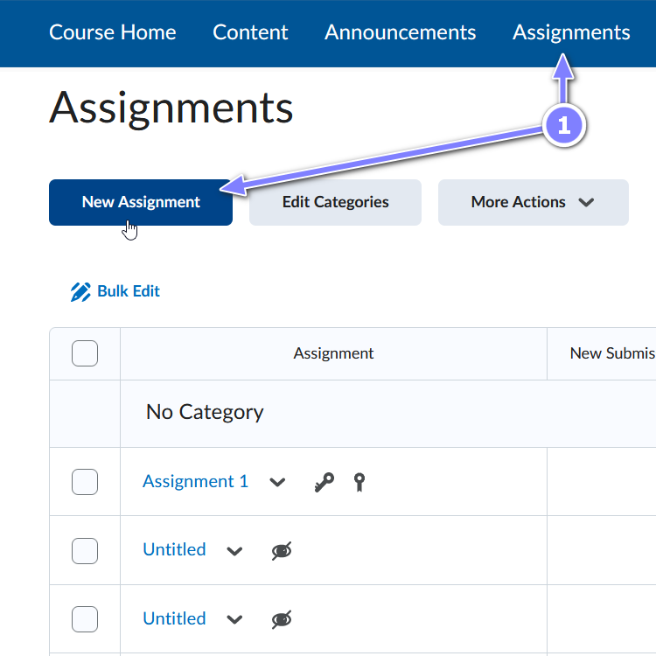 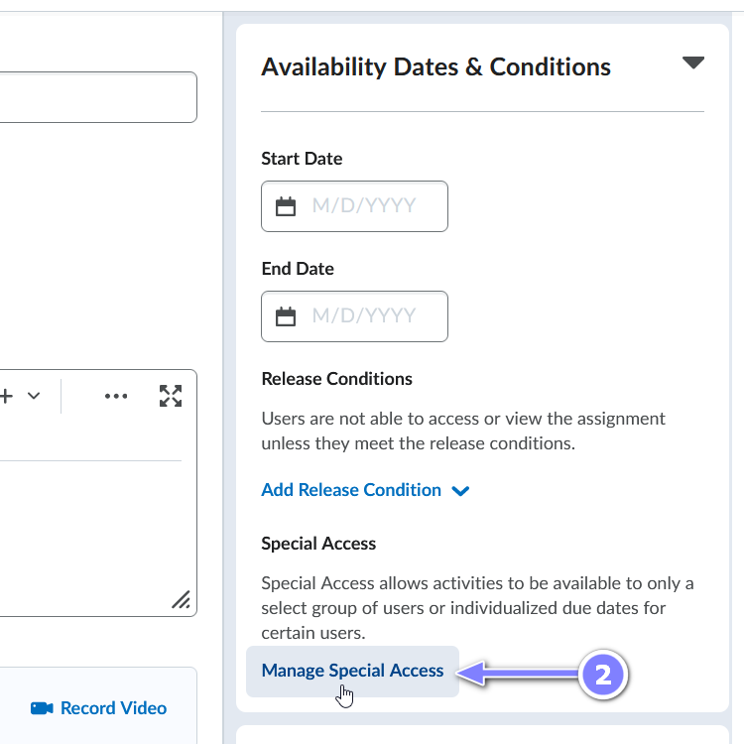

1. On the new pop-up window, make sure the first option is selected and click **Add Users to Special Access**.
2. In the next pop-up window, set the desired accommodation settings under **Properties** section.

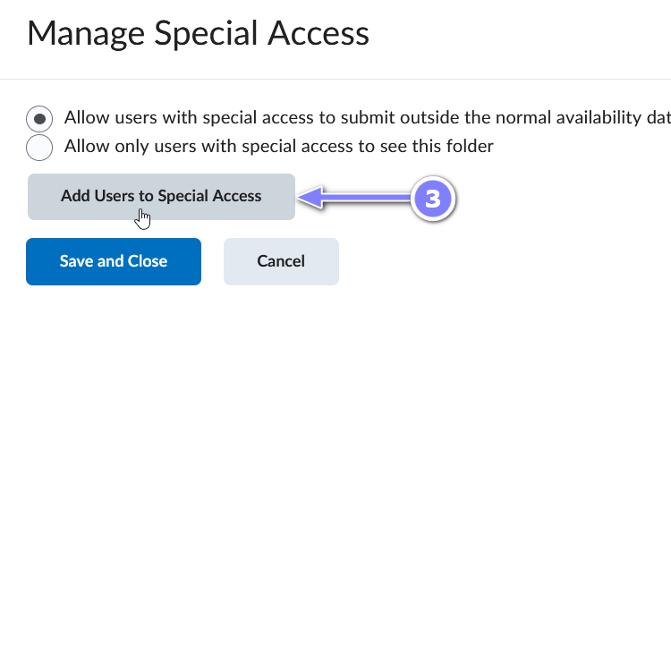 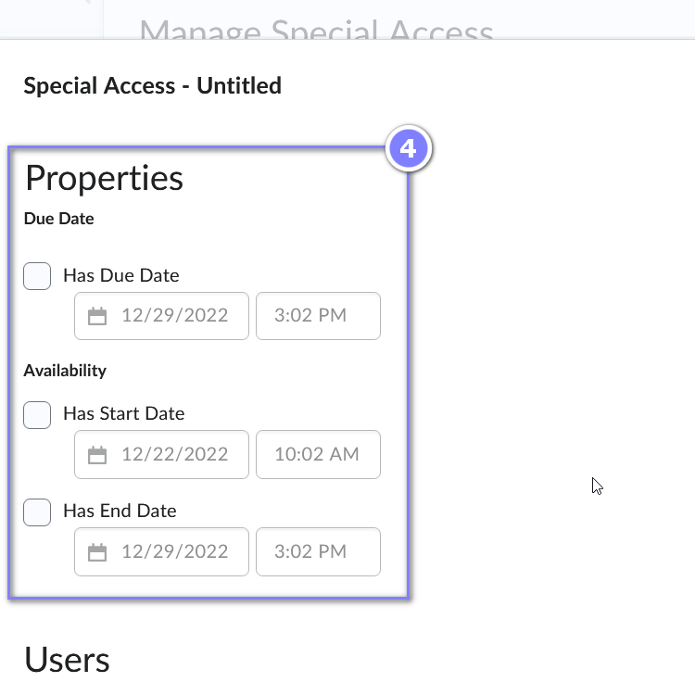

1. Scroll down to the **Users** section and select the students for this accommodation by clicking in the check box to the right of the student’s name and click **Save**.

