Edit Course Navbar
- On your course homepage, hover over the right end of the Navbar to make the 3 dots visible, click on them and select Customize This Navbar. Then click “Yes” in the confirmation pop-up box. (If you’ve done this before, you’ll see “Edit This Navbar” instead.)
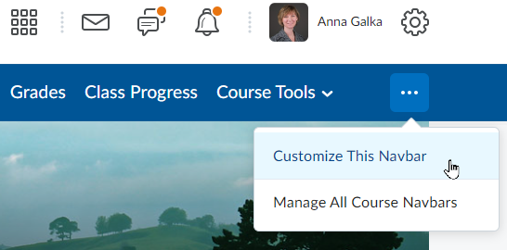
- To remove an item from the Navbar, click the “X” for that item, or if the item is under Course Tools, click on Course Tools and then click the “X” for the item you want to remove and click Save.
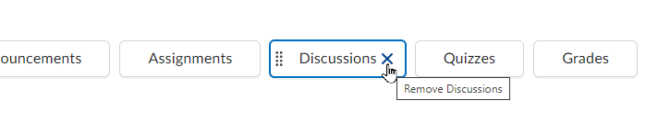
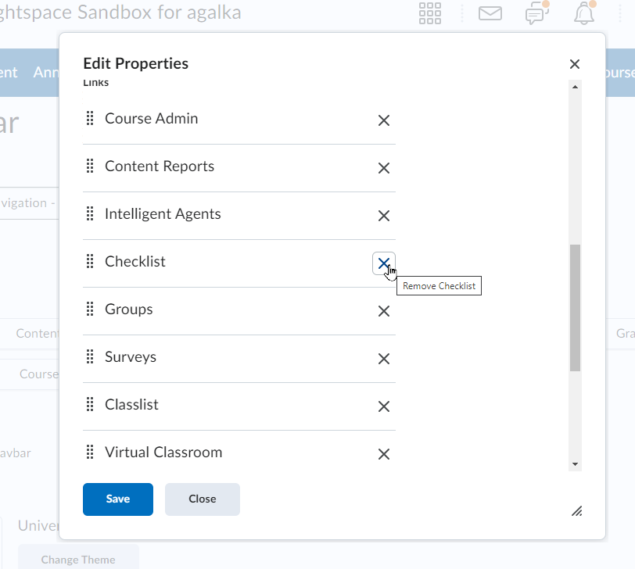
- Click Save and Close.
IMPORTANT: Do not remove Course Admin from your Navbar.

