Content: Delete a Module

- In your course, select Content in the Nav bar
- In the Table of Contents, select the module you want to delete.
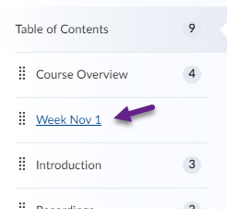
- Select the chevron to the right of the module’s name and in the drop-down menu, select Delete Module.
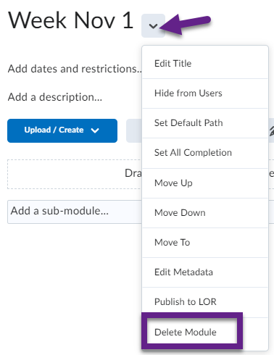
- In the dialogue box that appears, leave the default option selected to ensure items you linked to in your module does not get deleted from your course.
