Creating Grade Items in Excel

and Importing to Brightspace

When importing grades from MS Excel into Brightspace, it is essential to follow all the formatting principles outlined in the LMS (Learning Management System) to successfully import your grades. Here are some important formatting points that you can use to create and import new grade items from Excel into the Brightspace LMS:

Accepted Grade Items:
- Numeric
- Pass/Fail
- Text Grade

To create a Numeric Grade Item:
The column title must be Grade Item Name Points Grade <Numeric> (Grade Item Name is the name you have given to your assessment.)
Note:
- You cannot input textual elements for student grades (only numerical values).
- Any errors with cell data for student grades will not get imported.

To create a Pass/Fail Grade Item:
The column title must be Grade Item Name Points Grade <Pass/Fail> (Grade Item Name is the name you have given to your assessment.)
Note:
- The cell data for each student’s grade must either equal 0 (for a failure) or the maximum points of the assessment (for a pass), which can be any number greater than 0, specified during the grade item creation in Brightspace.
- Example: Assigning a 0 to a student is a failure for them and assigning 100 to a student is a pass for them, if the maximum number of points specified is 100.
- Any other number will have an error associated with it, and not get imported.

To create a Text Grade Item:
The column title must be Grade Item Name Text Grade <Text> (Grade Item Name is the name you have given to your assessment.)
See examples in Step 4 below.

Live Grade Item Creation in Excel and Importation in Brightspace:

- In your gradebook, click Export to export your grades.
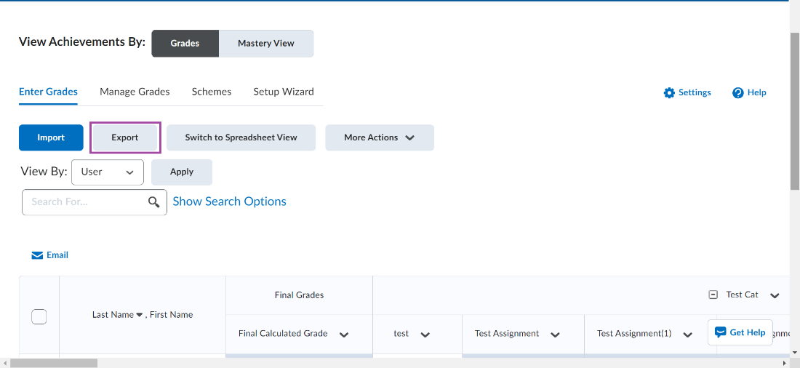
- Select the grades you would like to export and click Export to CSV.
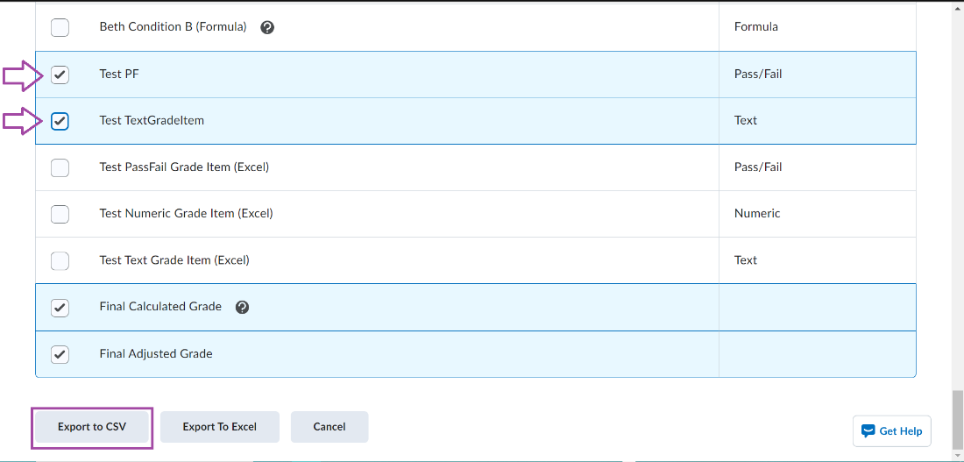
- Once you export your desired grade items to a CSV file format, your file should look something like this when displayed in Excel with the following grade items.
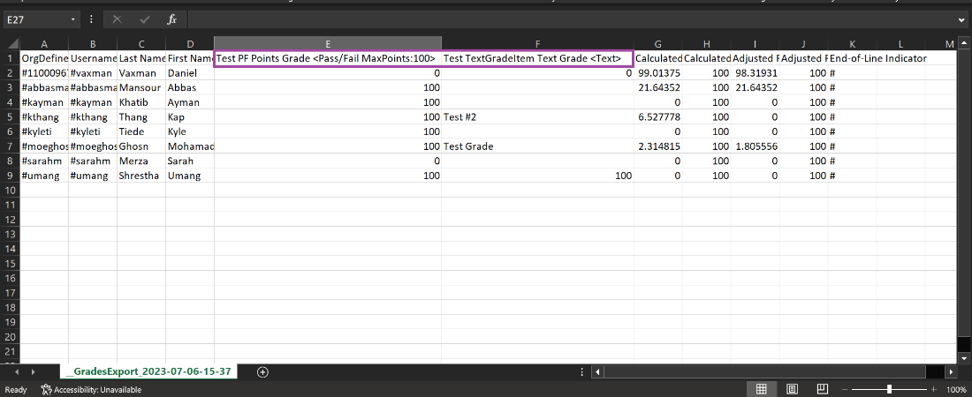
- In the example below, three new grade items were added to a CSV spreadsheet (a pass/fail grade item, a numeric grade item, and a textual grade item) by inserting columns into the spreadsheet, adding a column heading (as specified above in Accepted Grade Items), and manually adding student grades into the column’s cells:
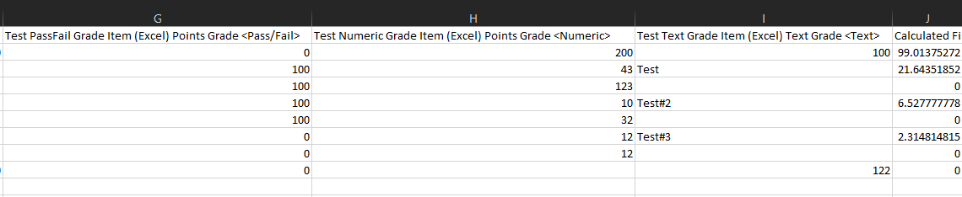
- Once completed, save the CSV file.
- In your Gradebook, click Import.
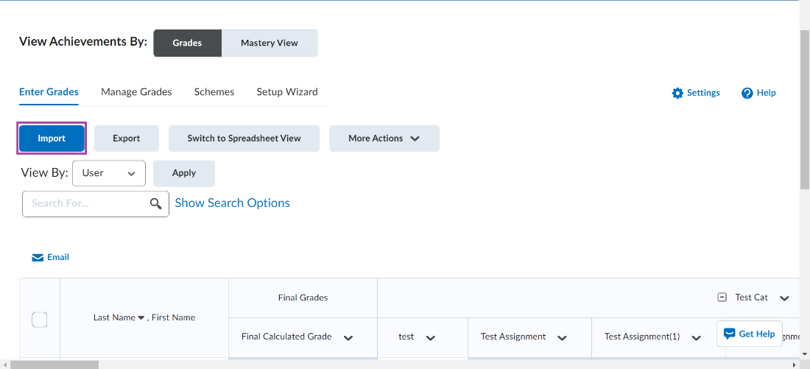

- Click the checkbox Create when an unrecognized item is referenced and click Continue.
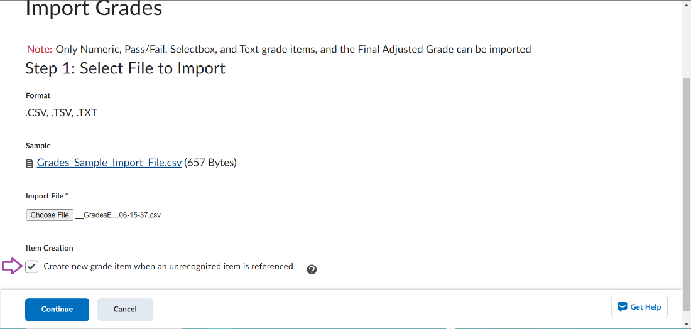
- You should be able to see all the new grade items that were inputted in the Excel file. Click Continue.
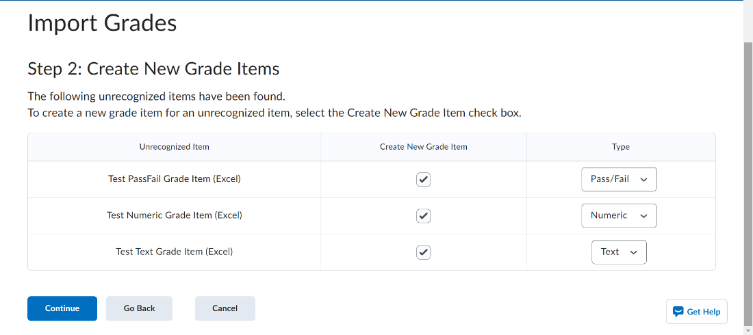
- You should see all the updated grades for each student. Click Import to import all the newly created grade items with the student grades.
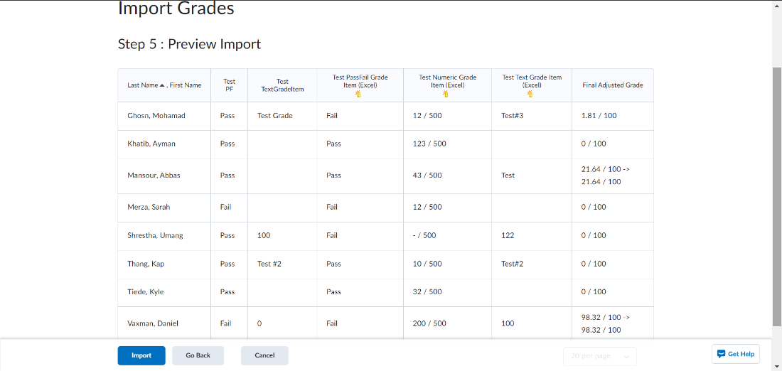
- This is what the new gradebook would look like based on the grade items and student grades in the example.
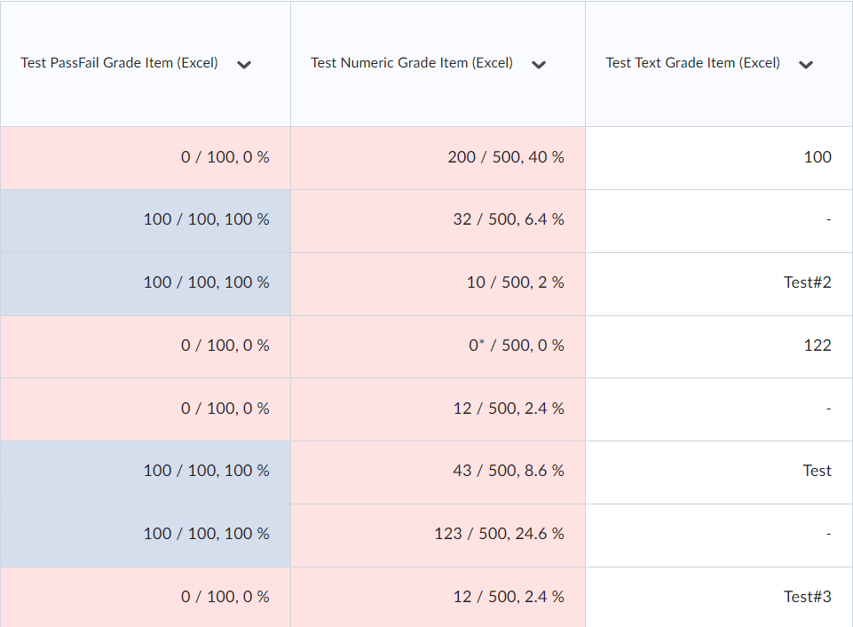

NOTE:
If you inputted any invalid grades in any cells, Brightspace will provide a warning that the invalid grades will not be imported. You can Go Back, make corrections to the spreadsheet and re-import, or Continue with the import and make the corrections in Gradebook once completed. 