Change the course banner image

- On your course homepage, hover over the right of the banner image until you see three dots appear. Click on those dots.
- In the drop-down menu, select Change Image.
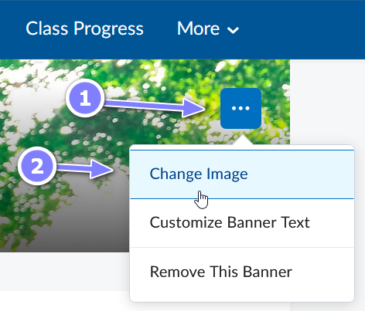
- From the Change Image dialogue box, use the Search bar to find an image relevant to your course by typing in a key word and pressing Enter on your keyboard. (If you prefer, you can upload an image from your computer by clicking the Upload link in the top right.)
- Select an image by hovering over it and clicking on the Use this image box that appears. The image will be placed in your banner.
Note: If you choose to upload your own image to use, the recommended size is 2400 x 960 pixels