Brightspace

Learning Object Repository (LOR)

Table of Contents
Table of Contents 1
What Is the Brightspace LOR? 1
Features 2
What file types does LOR allow? 2
Accessing the LOR 3
1. From the Brightspace landing page: 3
2. Add LOR to course navigation bar: 3
3. Access LOR from within tools: 5
How to publish to LOR 6
How to retrieve an object from LOR 8

What Is the Brightspace LOR?
The Brightspace Learning Object Repository (LOR) is a repository for faculty and instructors to use to store, organize, and discover learning materials. It allows users to create, upload, and share a wide range of educational resources such as documents, presentations, multimedia files, quizzes, assessments, and more.
You can publish (save to the LOR):
- All course content topics and modules such as quizzes, assignments, rubrics, and more
- Single or multiple Content modules
- Single or multiple Content topics
Brightspace LOR encourages collaboration and resource sharing among educators seamlessly integrated with Brightspace. You can hide your uploaded learning object from search results as well as choose if you would like to upload to a public or private repository.

Features
The Brightspace LOR offers several benefits, such as:
- Collaboration: Instructors can share their resources with colleagues, fostering collaboration and the exchange of best practices.
- Resource organization: It provides a structured and easily searchable environment for managing learning materials, allowing instructors to efficiently search for and use resources.
- Version control: It allows for the versioning of resources, ensuring that the most up-to-date materials are available.
- Quality control: Users can rate and review resources, helping others identify high-quality materials.
- Accessibility: Brightspace LOR supports accessibility features, making it easier to find and use materials that meet specific accessibility requirements.

What file types does LOR allow?
Object Type | File Type
Files (any type) | HTML, images, PDF, DOC/DOCX, PTT, video, etc.
Quizzes and Quiz Questions | Usually a .zip file (exported via Brightspace)
SCORM objects | Usually a .zip file (exported via Brightspace)
Inspired by: Publish to Brightspace Learning Repository - Brightspace (d2l.com)

Accessing the LOR
You can access the LOR in several ways.

From the Brightspace landing page:
On the Brightspace landing page, click LOR in the navigation bar.

Add LOR to course navigation bar:
If you want your students to be able to easily access the LOR, you can add the LOR link to your course navigation bar.
- Click the three dots to the right on the navbar. Select Customize This Navbar and when you are asked to create a copy. Select Yes. If you have already customized your navbar, you will see Edit This Navbar rather than Customize This Navbar and select that instead.
- Click Add Links.
- From the menu, select LOR and click Add.
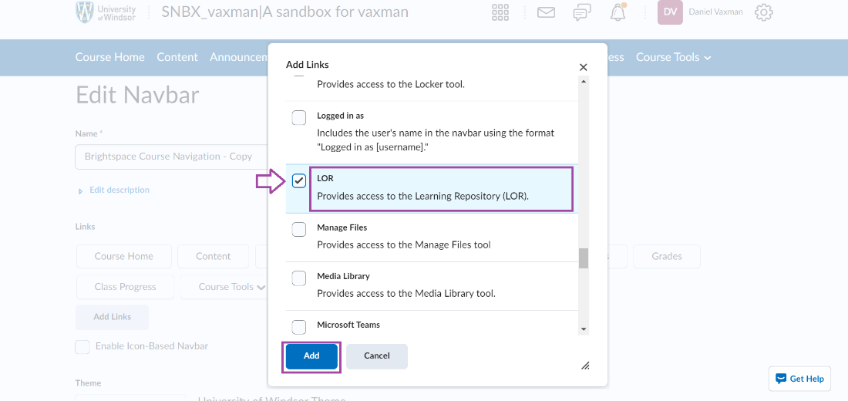
- You can change the order of the links in your navbar by dragging the LOR link to the position you would like it to appear in. When done, click Save and Close.
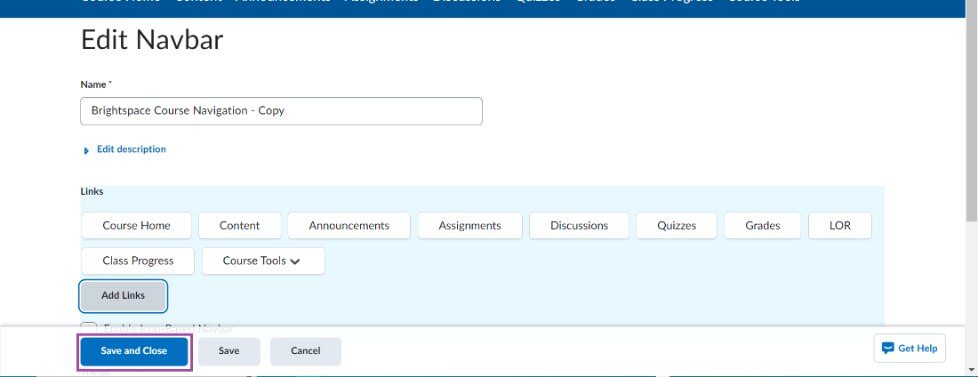
- You will now see the LOR link in your course navbar.

Access LOR from within tools:
A common way to use the LOR is by adding to the LOR or pulling from the LOR while in the tools of your course
- While in the Content area of your course site, you can select to add LOR objects using the Upload/Create button.
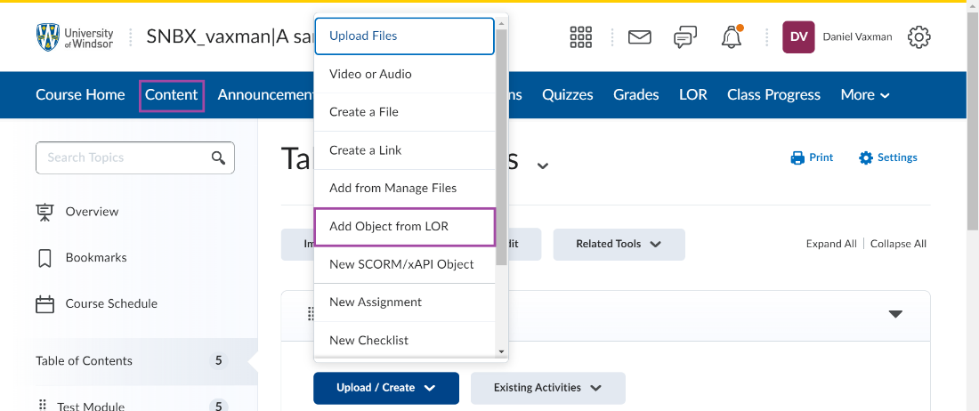
- While in the Quizzes tool, you can save a quiz to the LOR by selecting the you have created and publish to the LOR for future use by you or other faculty members.
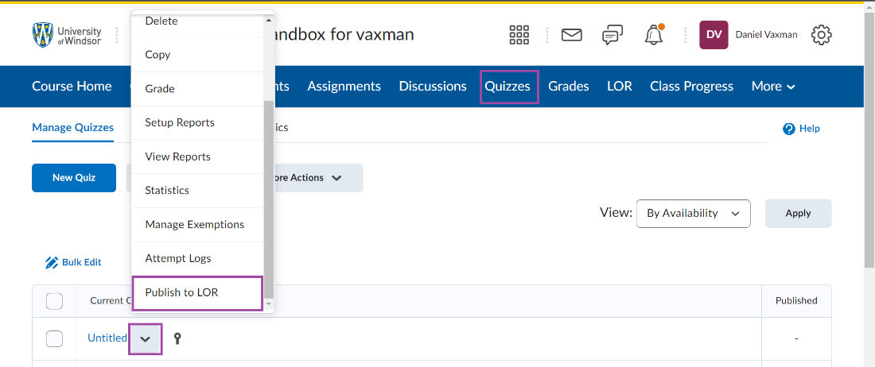

How to publish to LOR
Once you’ve added the LOR link to your navbar:
- Find LOR in your navbar. In this example, the LOR link is under Course Tools in the navbar. Click LOR to open it.
- Click Publish.
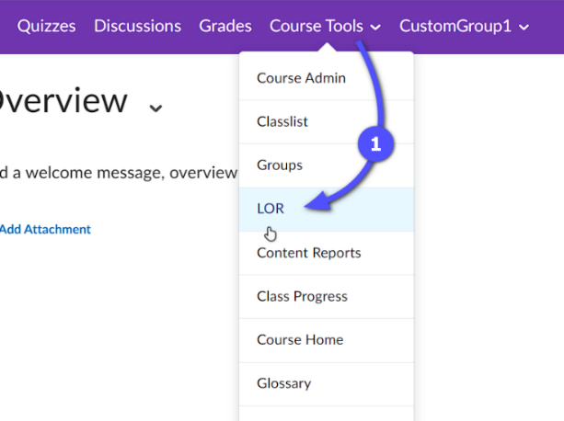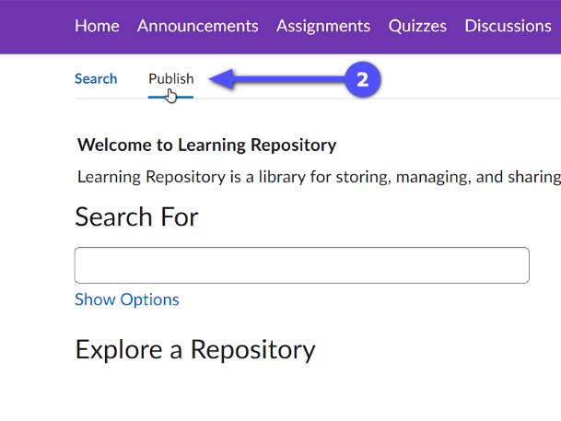
- Browse for a file or package or drag and drop a file or package on your computer (refer to the accepted file format table above) or provide a direct URL link to a web file.
- Under Publish To:
  - Select Pick a Repository if you’re publishing a new object and select a repository to publish to. The University of Windsor has
    - a Public Resources repository, meant for sharing objects beyond the university community, and
    - a UWindsor Resources repository, meant for sharing objects within the university community or kept hidden.
  - Select Overwrite Existing Object if you are updating an object already shared in the repository.
- Sharing and Publishing Options
  - Publish in the background:
    - Select this option if your file is large so it’ll be processed in the background.
  - Hide learning object in search results:
    - Select this if you want to share it only with those to whom you provide the direct link to the object. The object will not be viewable in search results.
  - Associate Creative Commons licence with Learning Object:
    - Select this to allow other users to modify and/or share your object.
    - Select an option from the dropdown.
- Click Next.
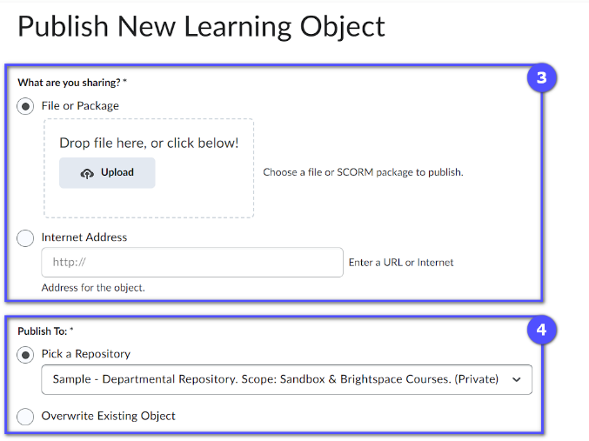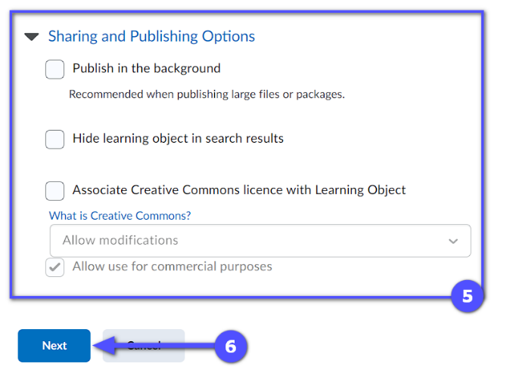
- Adjust the title, description, and keyword metadata. These metadata are useful for searching in the LOR.
- Click Publish to complete the process.
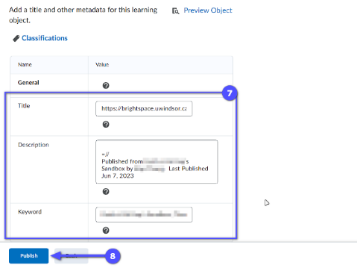

How to retrieve an object from LOR
- Find LOR in your navbar. In this example, the LOR link is under Course Tools in the navbar. Click it to open it.
- On Search page, type in your search query in the box and press Enter or click Search.
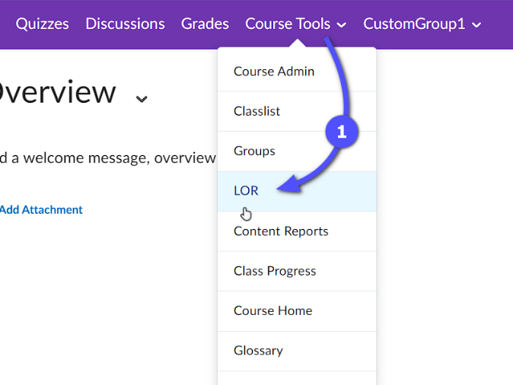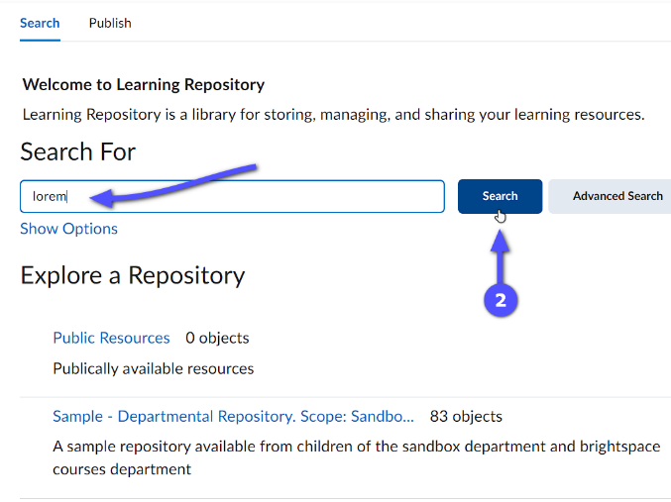
- In the result table, click the name of the file you searched for.
- Click Retrieve to start the retrieval process.
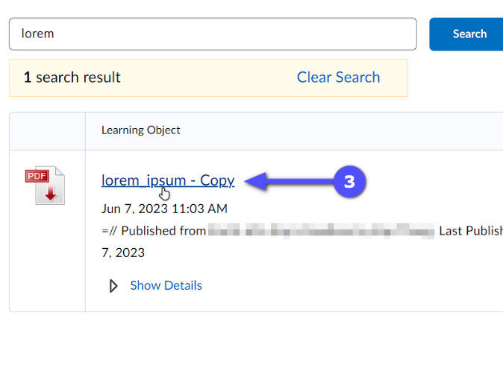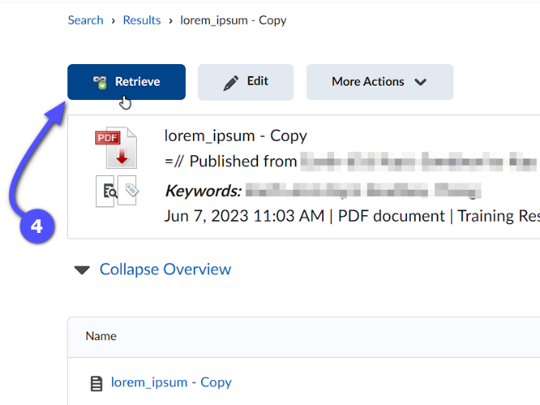

- You’ll be presented with several retrieve options; select one that fits your need. 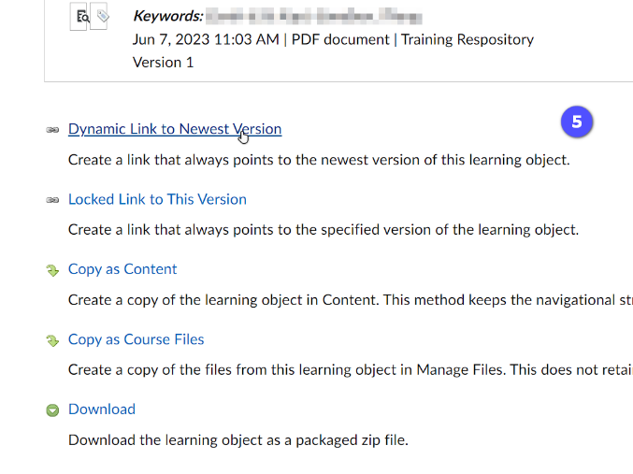
- Either select an existing module from the dropdown menu or click add module to create a new module for where this object will be placed in. Click Create Topic, Copy or Download (depending on what you’ve selected in step 5).
- Click Done to complete the process.
